**QwikLab: Intro to DynamoDB**

Time spent: 30min

**What I learned:**

* How to create DynamoDB
* How to add data to the table
* How to edit item
* How to query the table

**What I built:**

* DynamoDB table

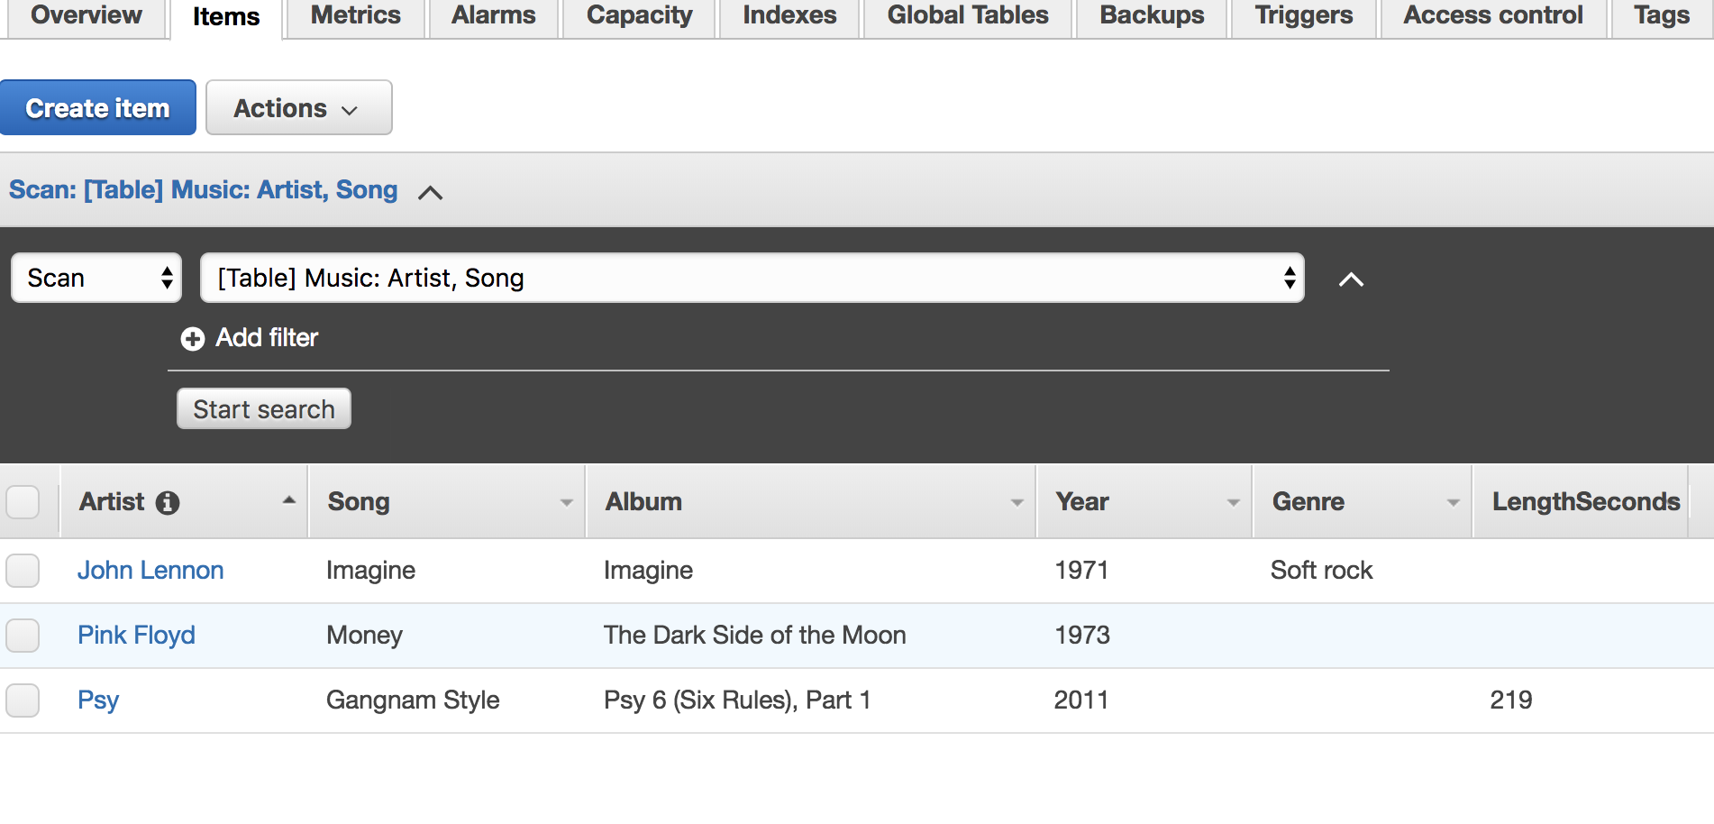

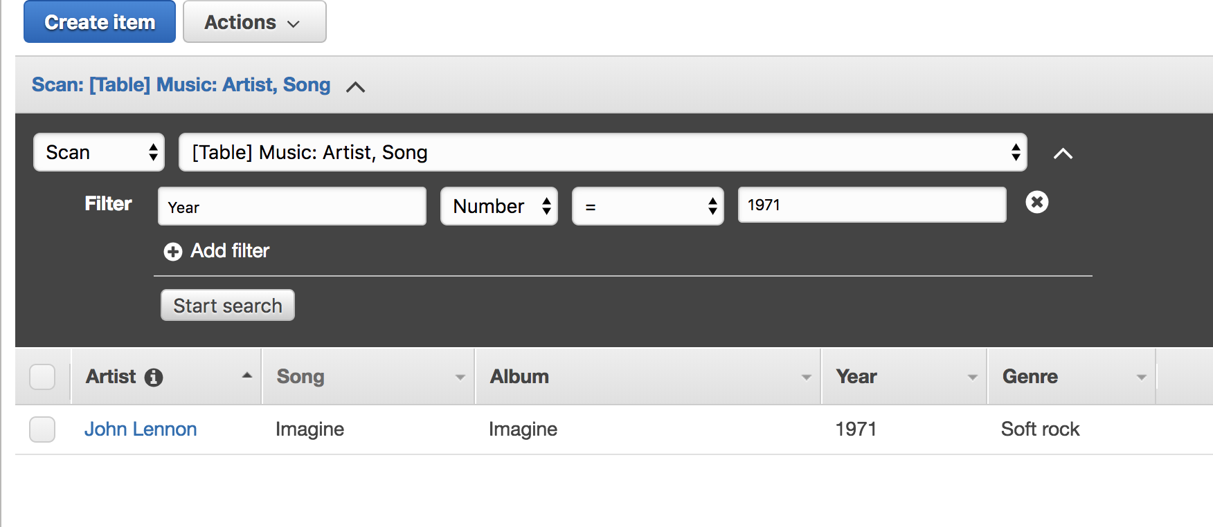

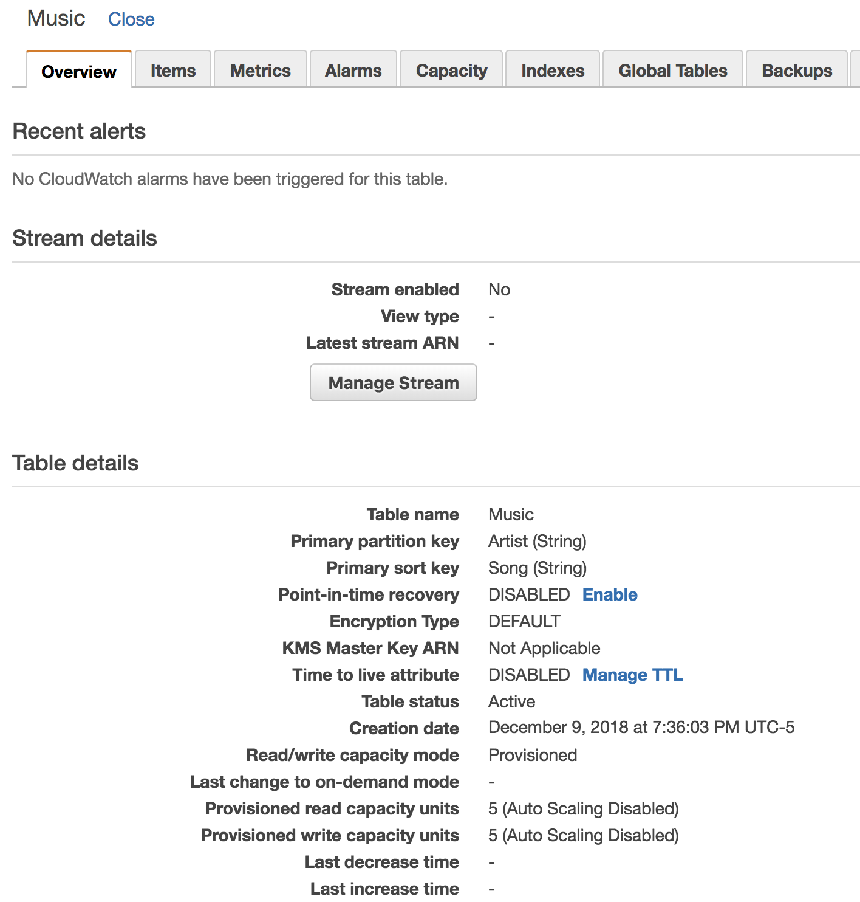

**Summary**

DynamoDB is convenient tool to scan, query the table. This section taught me some basic functions about it.